# **Module Introduction - Product Analytics**

Dear Learners,  
Welcome to the Product Analytics module!

Here, we explore various aspects of product analysis, equipping you with essential skills for excelling in product and business acumen rounds of data science interviews

### **Module Importance**

* Product Analytics equips professionals to leverage data effectively for informed decision-making on product strategies, features, and optimizations.
* By analyzing product usage, customer feedback, and market trends, it provides deep insights into customer behavior, preferences, and needs.
* Thorough analysis of product metrics, market trends, and competition identifies growth opportunities and areas for improvement, driving business growth.
* Addressing root causes of issues affecting product performance enhances the development and management processes.
* Product Analytics allows organizations to tailor products to meet the needs and expectations of their target audience, thereby enhancing user satisfaction and loyalty.

### **Module Overview**

Our module consists of 12 engaging lectures, each designed to cover specific topics essential for mastering product analytics:

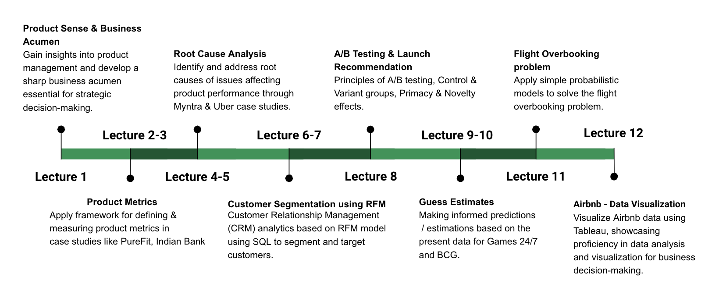

At the end of this module, there will be a **MODULE TEST** designed to evaluate and solidify your acquired skills.

### **Module Expectation**

* This module is crafted to develop your foundational skills in product analytics, laying the groundwork for you to excel in the product rounds of an interview.
* Product analytics offers vast opportunities, and while this module covers the basics, there's much more to explore beyond its scope.
* Completion of this module marks an important milestone, but it's only the starting point. We encourage you to engage in continuous learning through self-study and research.

### **Assessments & PSP**

This module walks you through essential concepts and practical techniques in product analytics, covering a range of topics across 12 lectures.

Sharpen your skills with solving assessments: **5+ assignments per lecture**

**Aim for a high PSP score (85+):** Demonstrates your proficiency in product analytics, a valuable addition to your resume and essential for data science interviews.

**Remember:**

* Seek help: Reach out to instructors or TAs for guidance.
* Track progress: Monitor PSP scores and adjust learning strategies accordingly.

### **Post-lecture Notes**

* We encourage you to regularly access **post-lecture content** via the dashboard.

### **Module Test**

* **At the module's end**, there will be a **module test** accessible through the dashboard.
* Module test/re-test is **90 minutes** long, with all learners eligible to take both tests, which include **MCQs**.
* Test launch dates will be provided at the module's end, and it's crucial for all learners to participate, aiming to pass the cutoff of **70 out of 100**.
* The next module will start in parallel with the module test.

### **Placement Eligibility**

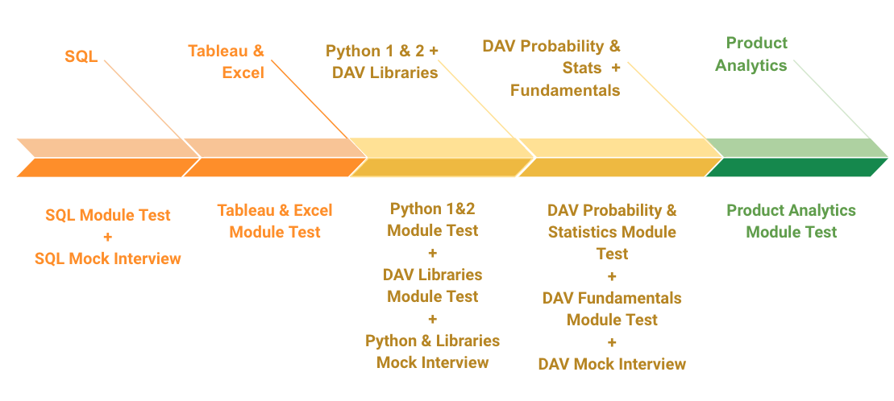

To become eligible for job placements, successful completion of all the following is required:

1. SQL module - Module Test + Mock Interview
2. Tableau & Excel module - Module Test
3. Python 1 & 2, DAV Libraries modules - Module Test + Mock Interview
4. DAV Probability & Stats, DAV Fundamentals modules - Module Test + Mock Interview
5. Product Analytics module - Module Test

Completing each of these components is crucial for your eligibility in job placements, and failing to complete either one will impede your qualification for placements.

#### **Ready to ace the Product Analytics interviews? Let's get started!**